Permitted Worker Permit

Important: This form can only be issued in accordance with Permitted Worker Permit Scheme Directions. If it is not issued in accordance with the Permitted Worker Permit Scheme Directions, it is invalid.

Individuals are not required to carry permits before 11.59pm Wednesday 5 August.
Employer details |  | [“Employer”]
Company name | AJ Grant Building Pty Ltd
ABN | 13 080 764 567
Company address | 38 Concorde Drive, Keilor Park VIC 3042
Trading name
[If different to company name]
Permitted industry/activity | Construction – critical repairs and restoration services to residential premises

Employee details |  | [“Employee”]
Full name | <Contractor Business Name & Name of Principal>
Date of birth
Residential address
Permitted Role for on-site work | Construction – critical repairs and restoration services to residential premises

Employee work location [If different to company address]
As per log for each job site
[If more than one, must be accompanied by a log recording each work location, and date and time of attendance]

Signed
Employer |  |  | Employee
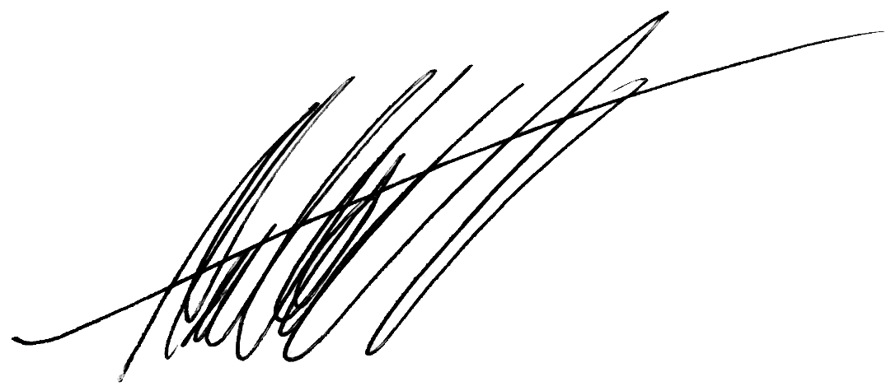  [Employer representative signature]  5 August 2020  [Date]  By signing this permit, the Employer confirms compliance with the Permitted Worker Permit Scheme Directions, including:  - attests that the workplace is compliant with the directions of the Chief Health Officer and the Occupational Health and Safety Act 2004, all reasonable steps have been, and will continue to be taken, to maintain a safe working environment for the employee, and has a COVIDSafe plan in place;  - attests that the employer is a Permitted Employer engaged in providing a Permitted Service;  - attests that the information provided on this permit is a true representation relating to a current employee and their employment details;  - acknowledges that the nominated representatives may be contacted if deemed necessary to confirm these details; and  - acknowledges the information provided by the employer in the Permitted Worker Permit is true and correct, and that presenting false, misleading or fraudulent information may incur penalties. |  | [Employee signature]  5 August 2020  [Date]  By signing this permit, the Employee:  - attests that their name, address, work hours, place of work, and employer, as contained in this Permitted Work Permit are true and correct that presenting false, misleading or fraudulent information may incur penalties;  - acknowledges that the nominated representatives may be contacted if deemed necessary to confirm these details and provides consent to the disclosure and collection of this information;  - understands the wording in this Permitted Work Permit relating to Diagnosed Persons and Close Contacts and agrees to not attend the Work Premises if either of these terms apply to the Employee's circumstances and will notify the Employer immediately if this occurs; and  - understands that if they develop symptoms or potential symptoms of COVID-19 they are not to attend or remain at the Work Premises and will immediately notify their employer.

Penalties
Completing this document with false or misleading information may cause you to be in breach of the Permitted Worker Permit Scheme Directions and liable to penalties up to $19,826.40 (individuals) and $99,132 (bodies corporate).

Hours of work
- Fill in either Table 1 or Table 2, as appropriate for the Employee’s working situation.
- Enter the Employee’s start and finish times for each day of the stage 4 restriction period.
- You do not need to include meal breaks or the total number of hours worked each day.
- Leave days blank or mark with an X when the Employee is not scheduled to work.
Table 1: Full-time employee (or working the same hours each week)
Rostered / scheduled work times
All weeks | Mon | Tue | Wed | Thu | Fri | Sat | Sun
[Example only] | 8.30–5.00 | 8.30–5.00 | 8.30–5.00 | X | 8.30–5.00 | X | X
3 Aug 2020 –
13 Sep 2020
Table 2: Part-time or casual employee (or working irregular hours each week)
Rostered / scheduled work times
Week | Commencing | Mon | Tue | Wed | Thu | Fri | Sat | Sun
[Example only] |  | 11.00–5.00 | X | 8.30–6.00 | 9.00–5.00 | 9.00–5.00 | 10.00–6.00 | X
1 | 3 Aug 2020
2 | 10 Aug 2020
3 | 17 Aug 2020
4 | 24 Aug 2020
5 | 31 Aug 2020
6 | 7 Sep 2020

Statement from the Employer
I declare that the Employer has taken all reasonable steps to avoid the necessity for the Employee to attend the Work Premises, but the Employer has determined that it is not reasonably practicable for the Employee to work from the premises at which the Employee ordinarily resides and the attendance of the Employee at the Work Premises is required for the provision of a Permitted Service of:
Construction – critical repairs to residential premises
[Nominate industry or nature of work undertaken]

Issued by nominated representative of the Employer
Nominated representative |  | Secondary contact
Full name | Cara Grambeau | Full name | Matthew Allenby
Title / Role | Executive Manager | Title / Role | Operations Manager
Phone number | 0451 371 265 | Phone number | 0447 021 107

Diagnosed Persons and Close Contacts
If a person is a Diagnosed Person or Close Contact for the purposes of the Diagnosed Persons and Close Contacts Directions (No 8) that person cannot be provided with a Permitted Worker Permit or permitted to enter or remain upon work premises.
An employer who completes a Permitted Work Permit for a person who is a Diagnosed Person or Close Contact may be in breach of the Permitted Worker Permit Scheme Directions and liable to penalties.
If an Employee is displaying symptoms or potential symptoms of COVID-19, the Employee must not attend the Work Premises and must immediately notify the Employer of these symptoms.

